Task 1: implement the lab as shown in the attachment files

Provide the screenshots of your work

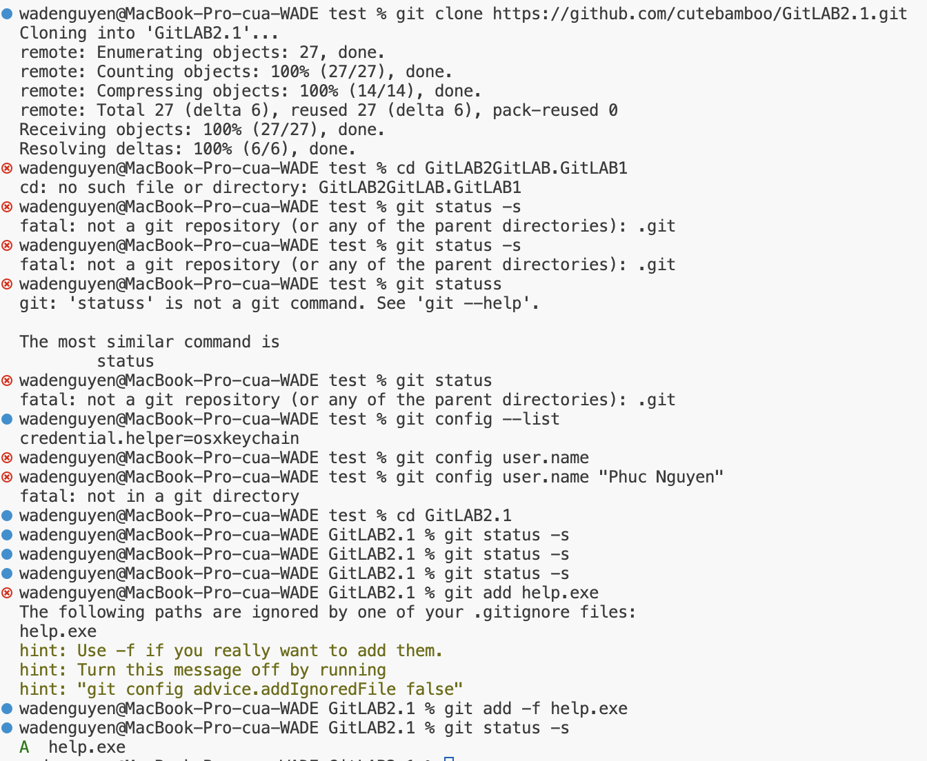

Task 2: Answer these questions?

Q1: After finishing step 4, what do git notify?



Nothing

Q2: After finish step 6, why notifications about the folder bin is no longer shown?

Q3: What is the main target of Step 7?

Not want to push this folder or files push to github

Q4: What are the notifications after doing Step 9? Why are these warnings shown? Does the CLI command in Step 9 work?

* Warning is shown
* CLI not work in Step 9

Q5: Why is file help.exe shown as being. tracked ?

Q6:  How can you unstage the file help.exe. Try to perform it and show the result.



Q7. What will happen if we delete the file .gitignore in the working directory?

Delete the .gitignore file in your working directory, it will not directly impact your Git repository's history or the actual tracked files in your repository.

(Folder bin and help.exe can push to github)